THE INFLUENCE OF WEATHERING ON THE STONE
AND PROTECTION OF STONE

Introduction

Basic components of air are nitrogen and oxygen. Depending on the type of surrounding, carbon dioxide, smaller quantities of sulfur and nitrogen oxides, water vapor, dust and unburnt debris of various fuels are also, more or less, present in the air. The atmosphere water contains the same ingredients as air, while some other waters also contain dissolved soil minerals. Water is a universal dissolvent, meaning that it can dissolve all the materials. When it is said that a certain material cannot be dissolved in water, it is meant that such a material can be dissolved in water to a very small extent.

Water and air as natural agents

Mechanisms of stone dissolving

Chemically speaking water is a polar substance. A molecule of water is dipole, in other words the ends of a water molecule, where you can find atoms of hydrogen, bear a partially positive charge while an oxygen atom is partially negatively charged.

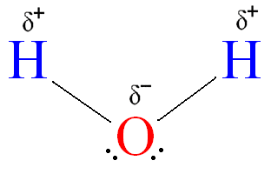

Crystal lattice of minerals also contains positively and negatively charged parts. There is electrostatic adhesion in the contact of minerals and water: by its positively charged parts water ‘attaches’ itself to negatively charged parts of minerals, while negatively charged parts of water molecule ‘attach’ themselves to positively charged parts of minerals. In this way, water molecules ‘pluck’ molecules of minerals from their lattice.

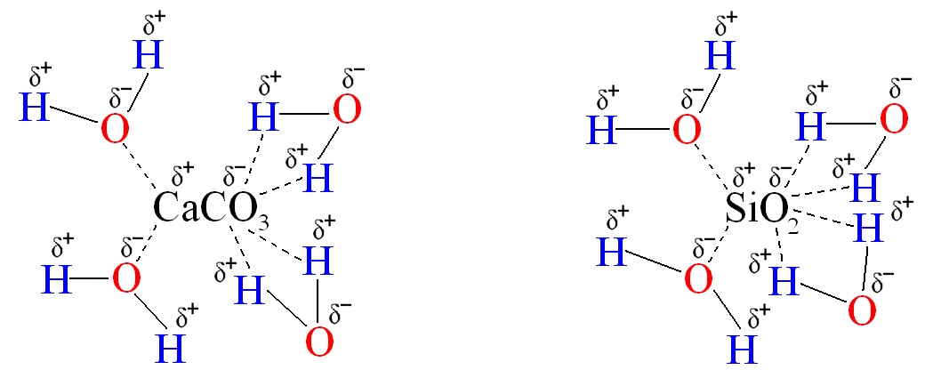

This process is called dissolution.

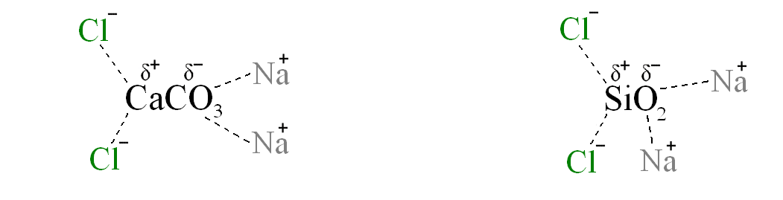
The presence of electrolytes dissolved in water influences considerably the speed of stone dissolution. Electrolytes dissolved in water are derived from acids and bases, which chemically changes the stone, or from salts, which represents the most frequent case. Sodium chloride (NaCl) or cooking salt, which is used for sprinkling the streets, has a significantly more intense reaction to the stone in the water dissolution than clear water. Cooking salt dissolved in water completely dissociates into positively charged sodium ions (Na⁺) and negatively charged chloride ions (Cl–). Similarly to the water molecules, positively charged ions of dissociated salt ‘attach’ themselves to the negatively charged parts of stone minerals, while negatively charged ions ‘attach’ themselves to the positively charged parts of minerals. Together with water molecules, ions of salt ‘extract’ molecules of minerals from their crystal lattice. The simplified mechanism of stone dissolution is the following:

Mentioned interactions occur in the presence of water and are far stronger than previously described interactions of clear water and stone minerals. Granites are the most susceptible to the influence of salt.

Damages of the stone are most frequently found on those parts of the building which are close to the ground and thus exposed to the influence of salt to the greatest extent.

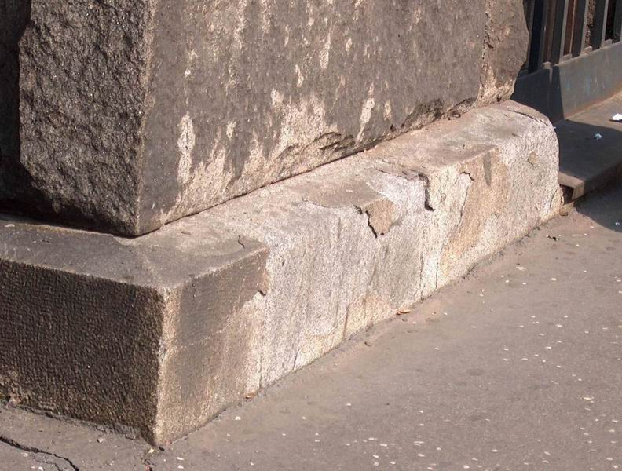
Belgrade, the Post building, southern facade: damages on the granite caused by salt

Carbon dioxide, as well as sulfur and nitrogen oxides, which can be found in the atmosphere to a much lower degree, substantially accelerate the disintegration of stone. All previously mentioned oxides are acidic and in the atmosphere they react with atmospheric water by producing appropriate acids. For example:

CO₂ + H₂O → H₂CO₃
carbon dioxide water carbonic acid

SO₂ + H₂O → H₂SO₃
sulfur trioxide water sulfuric acid

SO₃ + H₂O → H₂SO₄
nitrogen trioxide water nitrous acid

N₂O₃ + H₂O → 2HNO₂
nitrogen trioxide water nitrous acid

N₂O₅ + H₂O → 2HNO₃
nitric pentoxide water nitric acid

Carbonic acid is the weakest of all previously mentioned ones, but as it is found in the largest quantity its effect on the building material, in this case - stone, is the most important.
The effect of the carbonic acid on the limestone can be seen to the greatest extent. The reaction of limestone (calcium carbonate), which can be dissolved in water to a very small degree, and the carbonic acid produces calcium bicarbonate (calcium acid carbonate, calcium hydrogen carbonate) which is well dissolved in water:

CaCO₃ + H₂CO₃ → Ca(HCO₃)₂
calcium carbonate carbonic acid calcium bicarbonate
(poorly dissolved in water) (well dissolved in water)

In this way, carbonic acid disintegrates the limestone.

Sandstones, whose grains of sand are bound by clay and/or limestone, lose their binder by dissolving or dissolving and reacting with carbonic acid from the atmosphere. The loss of binder leads to the expansion of the pores and consequently to the loss of mechanical properties.

Other acids have a similar effect.
The speed of disintegration and dissolution depends considerably on the type of stone:
- if the stone has holes and/or pores, all the effects are present to a greater extent, so the disintegration is a lot faster,
- as a rule silicate stone is more resistant than the limestone.
________________________________________________________________________

The effect of water and frost on stone

At the temperature below 0ºC clear water changes into its solid state of matter – the ice. The atmospheric water always contains dissolved gases and other kinds of water polluters, which have a cryoscopic effect by reducing its freezing point. Water molecule belongs to the one of the smallest molecules. This characteristic enables water to penetrate easily into the stone interior. Once when it gets into the stone interior, water freezes at low temperatures. The ice, which is formed, represents a water crystal lattice. The pressure of ice crystallization mechanically damages the stone structure. In time, the repetition of this process leads to a complete disintegration of stone.

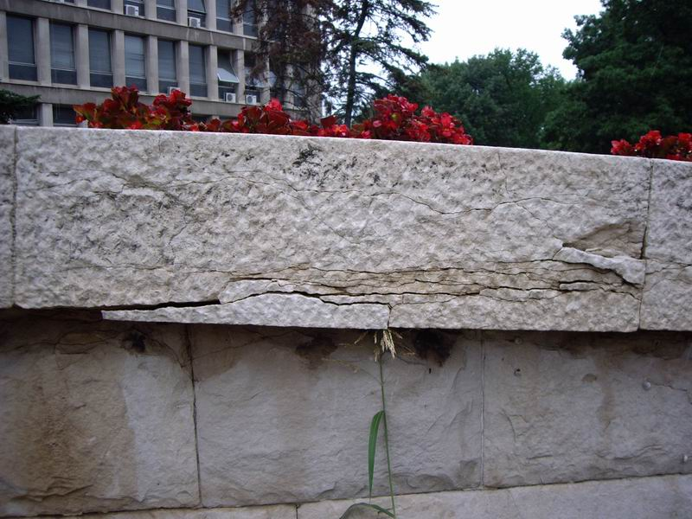
New Belgrade, the building of former Confederal Executive Committee: damages on the ‘Brac’ marble
________________________________________________________________________

The effect of water and warmth on stone

Water left in the stone and warmed by the Sun or in another way changes into its gaseous state of matter – water vapor. By evaporating from the stone water spreads and the pressure damages the stone.

The speed of stone disintegration depends on the type of stone, the size of pores in the stone, quantity of water in the stone, as well as temperature and speed of warming. The occurrence is most common in Mediterranean regions.

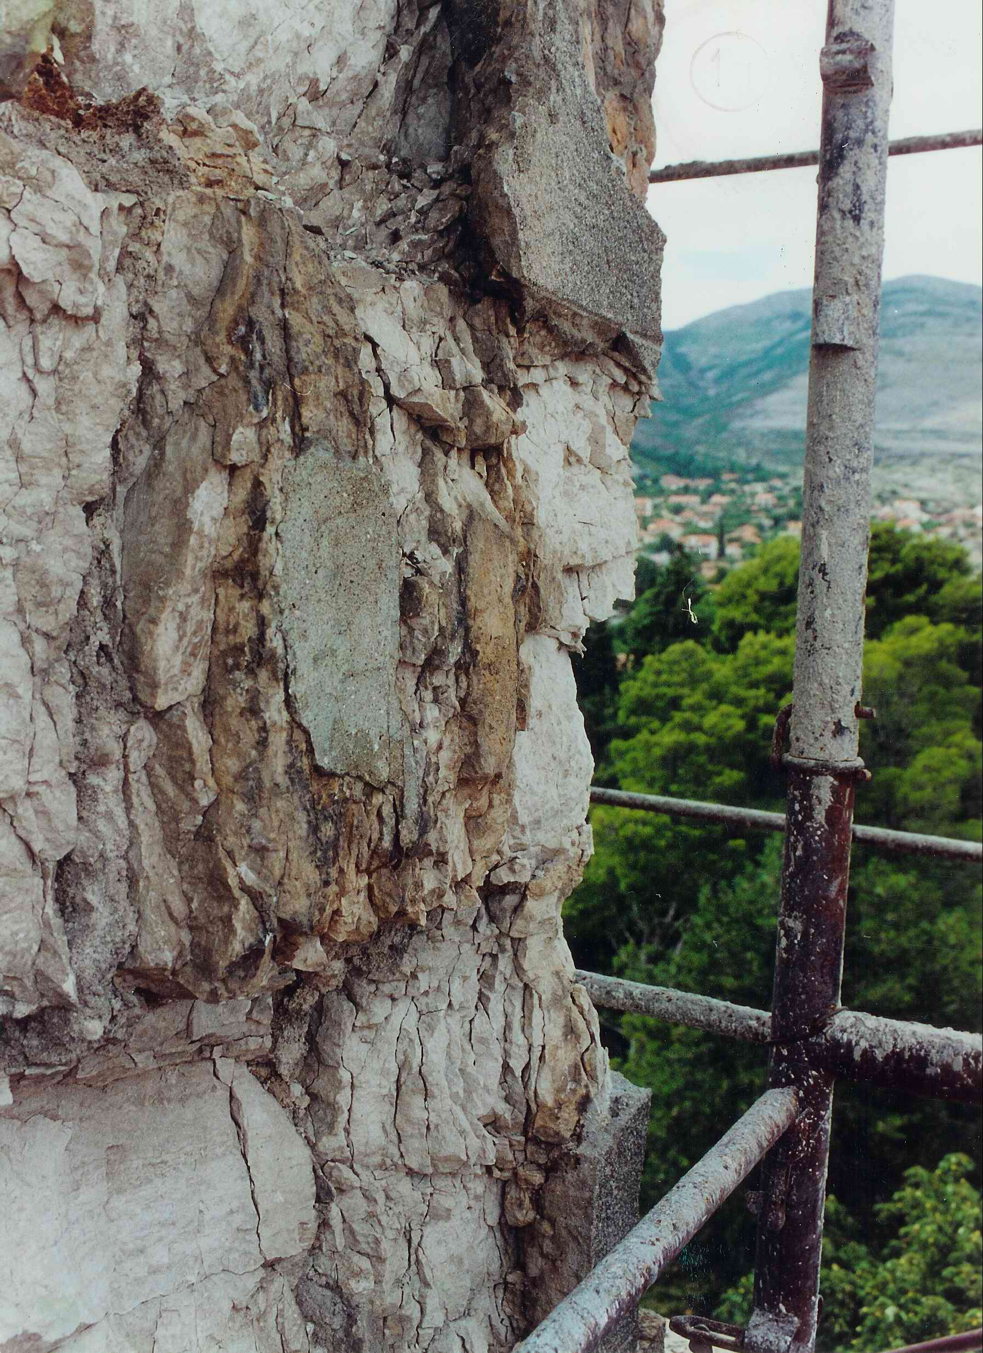

Trebinje, Transfiguration Temple: damage on the limestone
________________________________________________________________________

The effect of water and crystallization on stone

After the penetration into the stone water dissolves minerals, which it is made of, in a previously described manner. During a slow evaporation of water a part of stone minerals, which is dissolved in water, crystallizes again. However, this is done independently of a primary lattice structure. The pressures of such crystallization are extremely high, so this occurrence leads to the disintegration of stone structure.

The reaction of limestone (calcium carbonate) and sulfuric acid from the atmosphere, in the presence of water, generates calcium sulfate (gypsum rock), an extremely hard mineral.

CaCO₃ + H₂SO₄ + 2H₂O → CaSO₄ · 2H₂O + H₂CO₃
calcium sulfuric acid water calcium sulfate carbonic
carbonate (gypsum rock) acid

By volume a molecule of calcium sulfate is much larger than a molecule of calcium carbonate. The crystals of calcium sulfate generated in the reaction above using their crystallization pressure destroy marble and limestone. Carbonic acid disintegrates the stone in the above described manner.

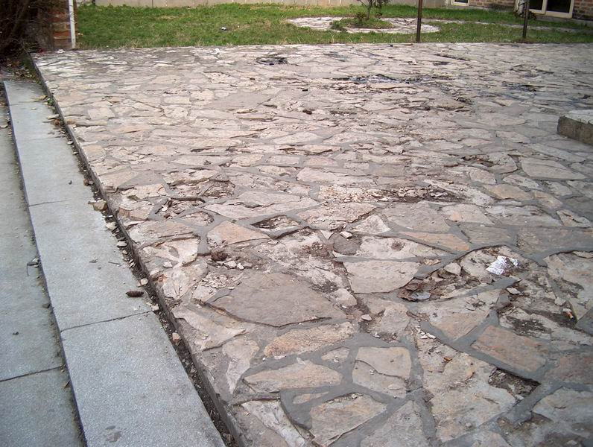
Belgrade, plateau in front of the cinema Sumadija: damages on the ‘Struganik’ limestone
______________________________________________________________________________

Salting out of stone (efflorescence)

Water takes a part of dissolved minerals to the stone surface. After the evaporation of water, minerals are left in the form of white or grey powdery spots or layers. This occurrence is known as salting out or efflorescence of building material, in this case – stone.

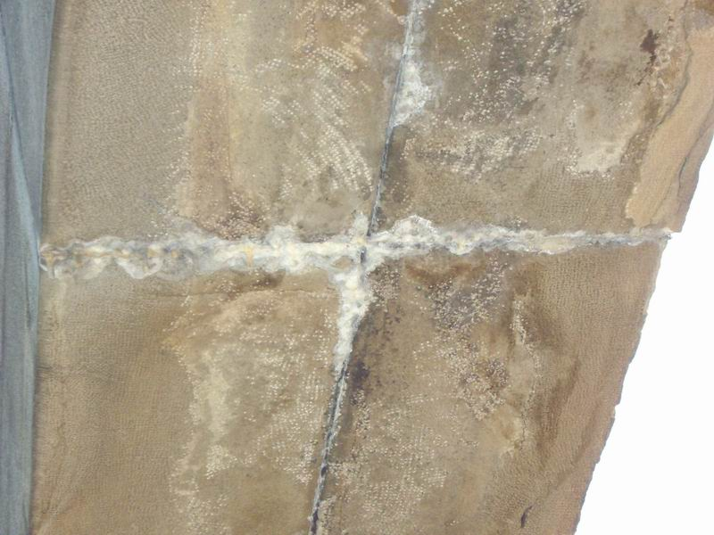
Belgrade, Monument of Belgrade liberators 1944, salting out of sandstone
______________________________________________________________________________

Swelling of the stone

Breccia and stones like breccia contain layered clay within the limestone. When clay gets wet, it swells and increases its volume. The side of the stone in touch with the atmospheric agents expands while getting wet and shrinks while drying, which in time leads to bending of the stone.

Mechanical properties are changing due to the rinsing of the clay with atmospheric water (rain).

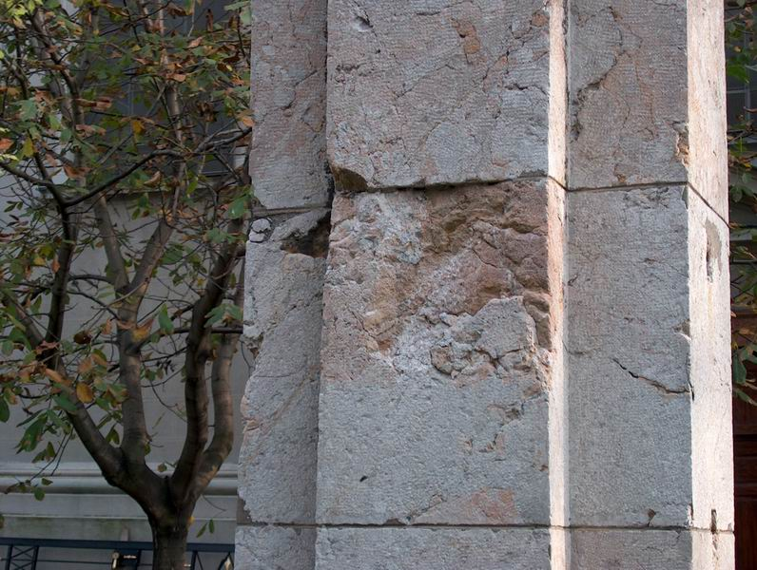
Belgrade, St. Archangel Michael Temple: damage on the breccia caused by rinsing of the binder (clay)
________________________________________________________________________

The influence of water and metal corrosion on stone

Iron and Ferrous-alloys are materials that are substantially used in the building industry. Iron corrodes (rusts) in the presence of humidity creating black and dark-rusty colored oxides:

2Fe + 2H₂O → 2Fe(OH)₂ → 2FeO + H₂O
black

4Fe(OH)₂ + O₂ → 2Fe₂O₃ + 4H₂O
dark-rusty

Owing to corrosion the volume of iron increases up to six times. Iron anchors and carriers, which are used in fixing stone parts and affected by corrosion, impose a huge pressure on the adjacent stone leading to the damages.

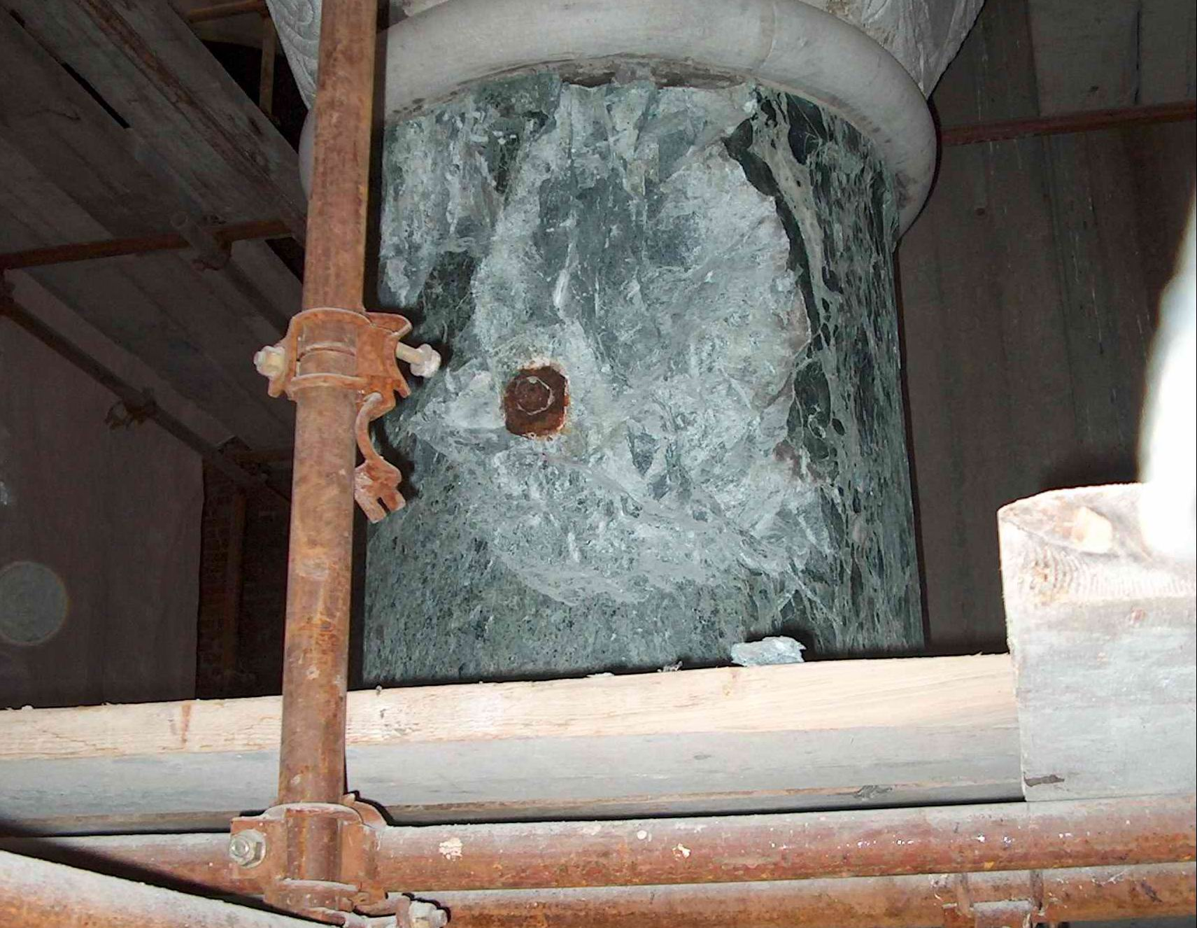
Belgrade, St. Sava Temple: damages on the ‘Alpi Verde’ marble column caused by corrosion of iron anchor
________________________________________________________________________

The effect of water on stone dirt

Rain and snow “collect” various particles of dirt and deposit them on the stone surface or take them into the stone. This occurrence is common in the cities, and it is seen especially in the vicinity of industrial zones where there is a great pollution of atmosphere.

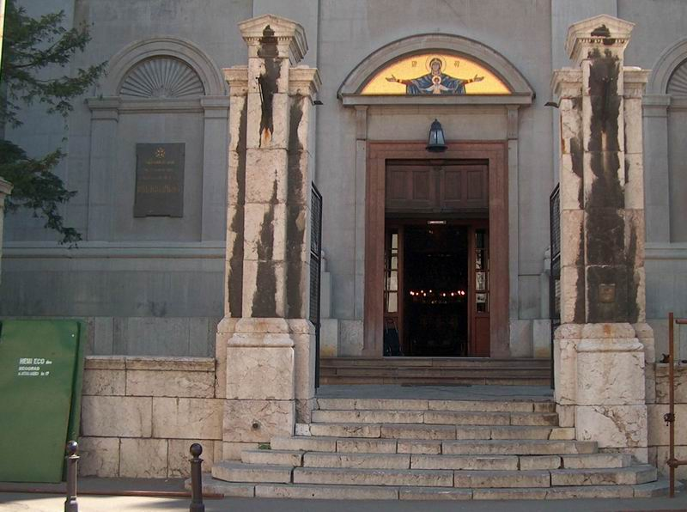
Belgrade, The Temple of Archangel Michael: layers of dirt on pillars of the main gate
______________________________________________________________________________

The effect of water on the growth of various organisms on the stone

Lichen, algae, mold and moss often use stone as their habitat, food or both. They are most frequently found on the northern end of the object, i.e. on the part of the stone where humidity is kept for the longest period. The most persistent and most resilient of all organisms are lichen which are formed with very little humidity and can survive at low temperatures.

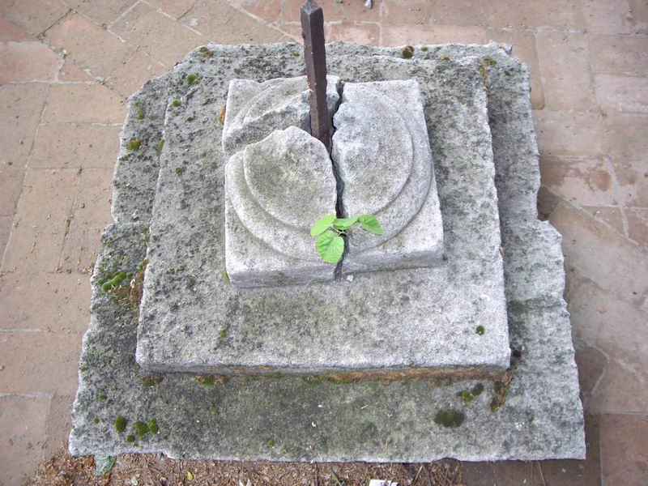
Zemun, St. Father Nikolai Temple, capital made of ‘Belovodski’ sandstone
______________________________________________________________________________

Protection of stone

The consequences of water effects are serious damages of building material. The protection of buildings against water and humidity is globally regulated by law, which everybody abides by.

Silicon products used in the protection of buildings against water and humidity are the most famous in the world and so far they have been unbeatable. The most common are the products such as monomers and polymers with hydrogen attached to silica:

R R R R
| | | |
C₁–Si–S , R’O–Si–OR’ , [–Si–O–]_{x} , [–Si–NH–]_{x}
| | | |
H H H H
Etc.

These silicon polymers are attached to stone by adhesion, so in that way it becomes water repellent.
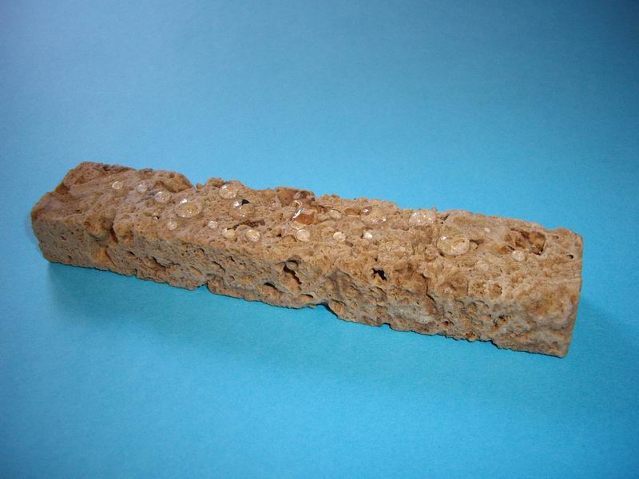
‘Cavern’ protected with Еco Impregnir K and Eco Impregnir MK, products of Development & Production Center ‘Hemi Eco’ from Belgrade

Water repellence of silicon polymers appears as the consequence of water repellence of radicals attached to silica.
Water repellence depends on the polymer structure; i.e. on the type of radical, degree of spatial networking of molecules and groups, which are, along with radicals, attached to silica.

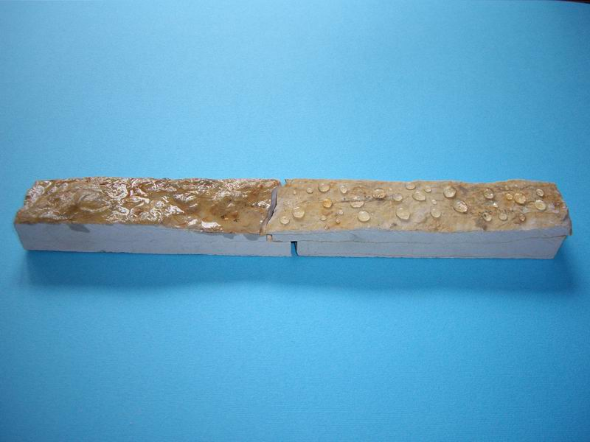
‘Struganik’ limestone: the right side is protected with Eco Impregnir K and Eco Impregnir MК, products of Development & Production Center ‘Hemi Eco’ from Belgrade

Bending of marble slabs is the topic of the European Research Project named ’Testing and Assessment of Marbles and Limestones’. Out of the concise results we present the following:

- Every stone is susceptible to bending,
- Bending of the stone is the consequence of structural weakness,
- Structural weakness can be minimised by water repellent protection of stone.

Stone becomes water repellent by protection (conservation), which eliminates negative effects of water starting from disintegration to dirt, as well as lichen, algae, mold, moss etc.

Antistatic effects of silicon prevent the electrostatic charge of a building.

Water, which in a way gets into a conserved material, freezes at very low temperatures that are not common in the conditions of natural surrounding (-100⁰C).
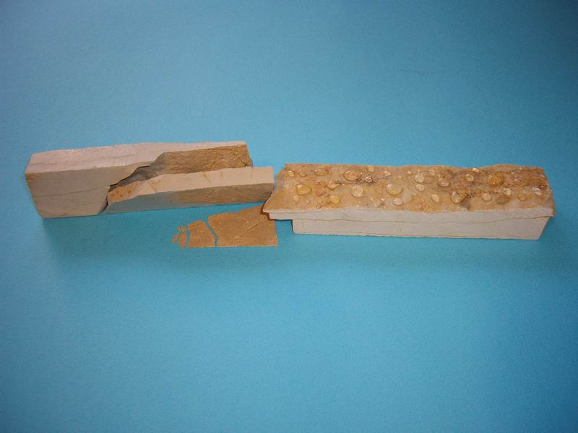
‘Struganik’ limestone after 10 cycles of freezing and unfreezing

Abstract

Besides wood and ground, stone is a building material that has been used for the longest period. Even today, the stone is used in the building industry because of its durability and irreplaceable appearance. Rain, snow, hail, wind, low and high temperatures and some other atmospheric occurrences affect and damage every building material. The protection (conservation) prolongs the lifetime of stone, as well as of other types of building materials. In developed countries the law regulates the conservation of building materials and silicone protective products, which are unequalled in their quality, are most often used for this purpose.

Development & Production Center ‘Hemi Eco’
Srećko Stefanović

Literature

- ”Long-term tensile and bending strength of natural building stones” Sorace, S, Materials and Structures, Vol. 29, August/September, 1996
- “Silicokone ihre Eigenschaften und ihre Anwendungsmöglichkiten“, 2. Auflage, Dr. rer. nat. habil. Hellmut Reuther, Verlag Theodor Steinkopff, Dresden, 1969
- ”Stone in Architecture: Properties, Durability”, Third edition, Winkler, E.M, Springer, 1997
- ”Thermal microfracturing of marble” Sage, J.D. Engineering Geology of Ancient Works, Monuments and Historical Sites, 1988

